**COMSATS University Islamabad,   
Abbottabad Campus**

**Project Proposal   
(SCOPE DOCUMENT)**

**for**

**Plant Disease Prediction System**  
Version 1.0

***By***

**Furqan Ahmad CIIT/FA21-BSE-089/ATD**

**Asad Khan CIIT/FA21-BSE-081/ATD**

**Abdul Muhaimin CIIT/FA21-BSE-061/ATD**

***Supervisor*JAVEED Raza**

***Bachelor of Science in Computer Science (2021-2025)***

Table of Contents

Abstract 3

Introduction 3

Problem Statement 3

Problem Solution for Proposed System 3

Related System Analysis/Literature Review 3

Advantages/Benefits of Proposed System 4

Scope 4

Modules 4

System Limitations/Constraints 5

Software Process Methodology 5

Tools and Technologies 5

Project Stakeholders and Roles 5

Team Members Individual Tasks/Work Division 6

Data Gathering Approach 6

Concepts 6

Tasks for 1st iteration (30%) 6

Gantt Chart 7

Conclusion 8

## Abstract

The project aims to develop a plant disease prediction system utilizing image recognition and machine learning. Users can upload images of diseased plants, and the system will predict the disease and suggest remedies. This system incorporates features like user authentication, plant health monitoring, disease diagnosis, weather data integration, and community support. The system intends to assist farmers and agriculturists in identifying diseases early, thereby mitigating crop losses and improving agricultural output.

## Introduction

The Plant Disease Prediction System is designed to assist farmers by providing early detection of plant diseases through image analysis. With the integration of machine learning, this system offers accurate disease diagnosis based on images of plant leaves or other parts. The goal is to reduce crop losses by offering timely intervention suggestions. This document outlines the scope and functionality of the system, which includes features like image upload, disease prediction, treatment recommendations, and plant health monitoring. The system will be user-friendly, accessible to a global audience, and support various languages.

## Problem Statement

Agricultural productivity is significantly affected by plant diseases, which, if not detected in time, can lead to considerable losses. Many farmers, particularly in rural areas, lack access to reliable tools for diagnosing plant diseases early. This results in delayed treatment, and often, the wrong type of treatment is applied, further damaging crops. Existing solutions may not integrate advanced technologies like machine learning or may lack accessibility, limiting their effectiveness for everyday farmers. Our project aims to bridge this gap by developing a system that uses machine learning to predict plant diseases accurately and provide actionable insights for treatment and prevention.

## Problem Solution for Proposed System

The system uses a machine learning model trained on a dataset of plant diseases to provide accurate predictions based on images uploaded by users. By integrating weather data, it can offer more precise diagnoses. The system also includes treatment suggestions and preventive measures based on the type of disease detected. Users can monitor multiple plants, view historical data, and receive notifications about plant health.

## Related System Analysis/Literature Review

**Table 1 Related System Analysis with proposed project solution**

|  |  |  |
| --- | --- | --- |
| **Application Name** | **Weakness** | **Proposed Project Solution** |
| Plantix App | Limited disease database | Larger, more comprehensive disease database with real-time weather data integration |
| Leaf Doctor | Only leaf disease detection | Supports detection for multiple plant parts (leaf, stem, fruit) |
| AgroAI | No offline support, limited to large-scale farmers | Offline access for small farmers and a community forum for support |

## Advantages/Benefits of Proposed System

* Early detection of plant diseases via image upload.
* Accurate diagnosis through machine learning.
* Integration of weather data to improve prediction accuracy.
* Real-time alerts and recommendations.
* Offline access for users in remote areas.
* Multilingual support for a global audience.

## Scope

The scope of this project includes developing a web application that allows users to upload plant images for disease detection. The system will predict diseases based on the uploaded images, offer treatment recommendations, and suggest preventive measures. The system will also provide historical data tracking, real-time alerts, and a community forum for user interaction. It will be accessible in multiple languages, ensuring global applicability. The weather and environmental data integration will enhance prediction accuracy.

## Modules

**Module 1: User Authentication & Profile Management**

* Users will be able to sign up, log in, and manage their profiles.
* Role-based access control will be implemented for different user types (farmers, experts, admins).

**Module 2: Disease Prediction via Image Upload**

* Users can upload plant images, and the system will preprocess and predict diseases using a machine learning model.

**Module 3: Plant Health Monitoring**

* Users can track the health of multiple plants over time, with predictions stored for later reference.

**Module 4: Disease Information & Recommendations**

* A comprehensive database of diseases will provide detailed information, treatment suggestions, and preventive measures.

**Module 5: Weather and Environmental Integration**

* The system will integrate weather data to enhance the accuracy of disease predictions.

**Module 6: Notifications & Alerts**

* Real-time notifications will alert users about potential plant health issues, and regular reminders will be sent for routine checks.

## System Limitations/Constraints

* Accuracy of predictions is dependent on the quality of uploaded images.
* The system requires constant internet access for real-time weather data.
* Prediction is limited to diseases the model has been trained on***.***

## Software Process Methodology

* The Agile methodology will be used for this project. Agile is suitable due to its flexibility, allowing iterative development and continuous feedback from users and stakeholders. The team can adapt the system based on evolving requirements and user feedback.

## Tools and Technologies

**Table 2Tools and Technologies for Proposed Project**

|  |  |  |  |
| --- | --- | --- | --- |
| **Tools**  **And**  **Technologies** | **Tools** | **Version** | **Rationale** |
| MS Visual Studio | 2015 | IDE |
| MS SQL Server | 2015 | DBMS |
| Adobe Photoshop | CSC 6 | Design Work |
| MS Word | 2015 | Documentation |
| MS Power Point | 2015 | Presentation |
| Pencil | 2.0.5 | Mockups Creation |
| **Technology** | **Version** | **Rationale** |
| JavaScript (React) | 6.0 | Programming language |
| CSS | 3.0 | Styling Library |
| Node.js/Django | 20.18 | Backend web framework |

## Project Stakeholders and Roles

Write down the project stakeholders and their roles.

**Table 3Project Stakeholders for Proposed Project**

|  |  |
| --- | --- |
| **Project Sponsor** | COMSATS University, Islamabad |
| **Stakeholder** | Mention your stakeholders with their roles and responsibilities.  Default option will be:   * Student: Asad Khan * Student: Furqan Ahmad * Student: Abdul Muhaimin * Project Supervisor Name: Sir Javaed Raza * Final Year Project Committee: Evaluation of project |

## Team Members Individual Tasks/Work Division

**Table 4Team Member Work Division for Proposed Project**

|  |  |  |
| --- | --- | --- |
| **Student Name** | **Student Registration Number** | **Responsibility/ Modules** |
| Asad Khan | FA21-BSE-081 | User authentication, role-based access  control, disease prediction model  integration. |
| Furqan Ahmad | FA21-BSE-089 | Plant health monitoring, weather data and  environmental factor integration. |
| Abdul Muhaimin | FA21-SE-061 | Disease information & recommendations,  notifications & alerts, and community  forum. |

## Data Gathering Approach

We will use provided dataset.

## Concepts

* Machine Learning: The core technology for disease prediction.
* Image Processing: Preprocessing uploaded images for disease detection.
* Weather Data Integration: Enhancing prediction accuracy by factoring in environmental conditions.

## Tasks for 1st iteration (30%)

* Design Use-Case Diagram , Detailed Use-cases.
* Design Class Diagram, Sequence Diagrams.
* Design ER Diagram, DFD diagrams (0,1,2)
* User interface designs
* User authentication and profile management.

## Gantt Chart

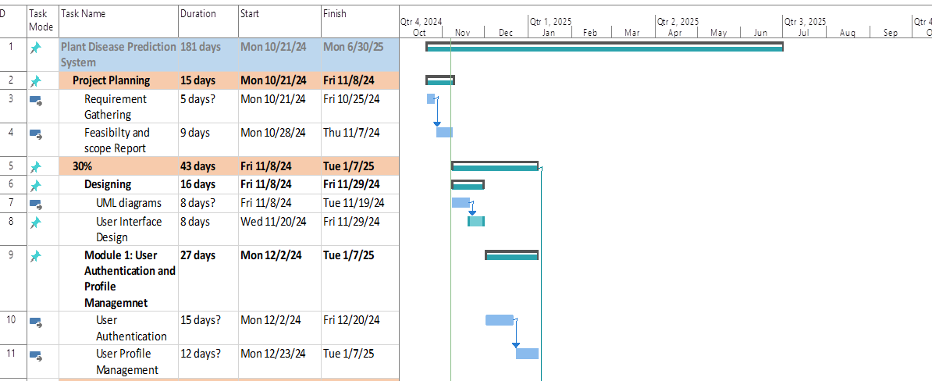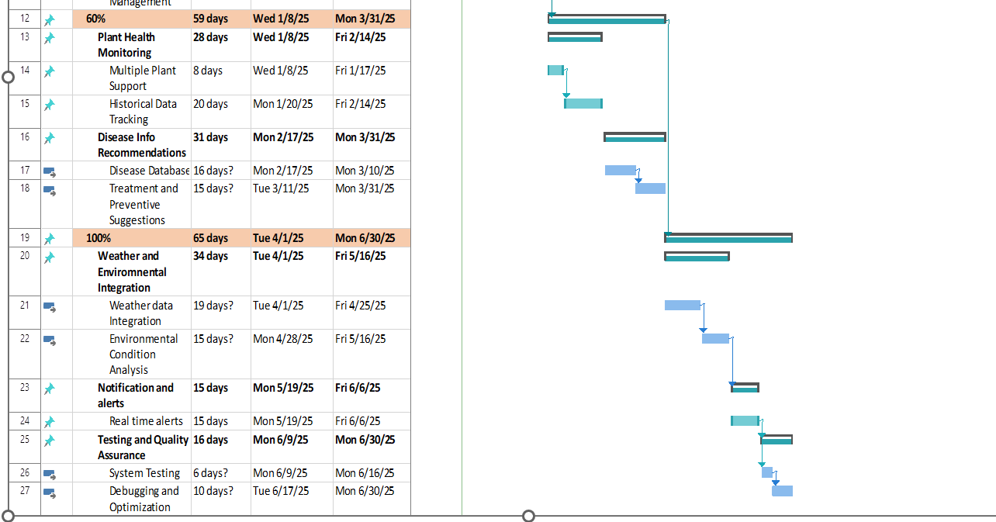

## Conclusion

This document outlines the project’s purpose, functionalities, and implementation plan. The system will use cutting-edge technology to assist farmers in diagnosing plant diseases, ultimately improving crop yield and reducing losses.